

**University of Colorado Denver**

**ISMG 6450**

**Tae Kim, Kunal Naik, Anirudh Rajan, Prathamesh Dhapodkar**

Table of Contents

Executive Summary (Tae Kim) 4

Integration(Tae Kim) 5

Overview 5

Preliminary Project Scope Statement 5

Project Management Plan 5

Project Execution 5

Monitor and Control Project 5

Integrated Change Control 6

Project Closure 6

Scope Management(Anirudh Sundar Rajan) 7

Scope 7

Key Members 7

Key Milestones 7

Figure #1: Milestones 7

Product Description 8

Time Management(Kunal Naik) 9

Plan Schedule Management 9

Defining Activities 9

Sequence Activities 9

Figure #2: Network Diagram 10

Estimate Activity Resources 11

Figure #3: Resource Chart 12

Estimate Activity Duration 12

Develop a Schedule 13

Figure #4: Gantt Chart 13

Control Schedule 14

Cost Management(Kunal Naik) 15

Estimated Budget 15

Monitoring/Controlling Budget 15

Figure #5: Time-Phased Budget 15

Figure #6: S-Curve 16

Figure #7: Planned, Earned, Actual Value Calculations 16

Quality Management(Anirudh Sundar Rajan) 17

Plan 17

Quality Checklist 17

Figure #8: Quality Checklist 17

Monitor and Control 18

Human Resource Management(Tae Kim) 19

Plan 19

Team Members and Responsibilities 19

Figure #9 – Responsibility Matrix 19

Communication Management(Prathamesh Dhapodkar) 21

Plan 21

Figure #10: Communication Plan 21

Risk Management(Prathamesh Dhapodkar) 22

Figure #11: Risk register 22

Procurement(Prathamesh Dhapodkar) 23

Plan 23

Outsourced Purchase 23

Subcontracted Purchase 23

Conduct Procurement 23

Figure #12: Expected Delivery Times and Contracts 24

Figure #13: Procurement Plan 24

Control and close procurement 24

Stakeholder Analysis(Kunal Naik) 26

Figure #14: Stake holder Influence vs. Interest Analysis Map 26

Lessons Learned(All) 28

References and Acknowledgements(All)………………………………………………29

# Executive Summary

Cheese Chase is an interactive and intuitive store, parking and restaurant locator developed by Rocky Mountain Technologies Pvt. Ltd. This company’s motive is to simplify life by providing solutions to everyday problems. The application Cheese Chase satisfies the company motto by saving valuable time of the customers by providing location services.

Cheese Chase is a software-hardware integrated solution bridging the digital world with physical spaces. It gives the users more control over their valuable time with superior experience of digitalization. It also works towards facility management, providing better product choices, parking availability which enhances the experience of a mall and increases the loyalty of its patrons. This will use mall Wi-Fi, blueprints and in-app built-in GPS with real time augmented positioning.

Cheese Chase provides services which enhance the mall experience for everyday shoppers and store owners. Real time store location helps customers reach their desired store without any hassles. Cheese Chase also lists restaurants present on premise and shows availability of on-site parking or at a nearby location.



# Integration

## Overview

Every day, millions of people around the world visit malls and restaurants, frustrated by the unavailability of parking, and the struggle of finding specific stores and restaurants. Oftentimes, due to unavailability of parking, people cancel their plans leading to frustration of the customers and loss of business for the mall and storeowners. Another major point of frustration is unavailability of tables at restaurants or not having prior knowledge of the restaurant.

This is where Cheese Chase comes into the picture. Our software enables patrons to find parking in or around the mall premises, enabling the patrons to spend more time on recreation. The mapping technology provides accurate locations for all the stores, kiosks and restaurants. The restaurant page also contains links to various review websites where people can stay informed on availability of tables as well as the reviews by other customers.

## Preliminary Project Scope Statement

Cheese Chase premier indoor mapping and location platform provides three main functionalities. A user needs to login to the app using Mall Wi-Fi which gives access to the mall’s floor plan, parking, store and eateries.

## Project Management Plan

This is a vital project which needs to follow the internationally acclaimed standards set by PMI in the Project Management Body of Knowledge (PMBOK). All ten knowledge areas decided by PMI have been taken into consideration in the development of this project.

## Project Execution

Stakeholders are vital in the development of this project. They are the main source of funding and allow for opportunities to network with shopping centers regionally. The stakeholders will stay in contact with the project manager on project updates. The project manager will have a team of developers and team leaders to successfully implement the project.

## Monitor and Control Project

Tracking and Monitoring the project is vital to complete on time and within budget. It is the Project Manager’s duty to track progress of the project within fixed intervals of time. The PMBOK has provided many tools and methods which facilitate tracking of progress such as Gantt Charts and Network Diagrams. After the preliminary scrum meetings, Gantt Charts help Project Managers to visualize and understand current progress vs ideal progress. This helps project managers to get a clear update on time and budget restraints, after which the project manager will update the stakeholders. The major areas that the Project Manager will focus on are Quality, Risk and Time Management.

## Integrated Change Control

This project is being developed using Agile Methodology. Agile enables us to dynamically develop the project and incorporate changes or new features at any point during development. Unapproved changes are taken to a panel consisting of Project Managers and Stakeholders.

## Project Closure

A project can only be as good as its closure. It is one of the most vital aspects in the successful completion of a project. The project in question needs to be closed with successful documentation, trials, prototypes, etc. in order to transpose onto future projects or to make changes within current project at any given time.

# Scope Management

## Scope

Cheese Chase provides three primary functionalities:

**Show Down**: Service which navigates you to the desired store turn by turn from the available stores in the mall.

**Chow Down**: Service which navigates you to the desired eatery turn by turn from the available restaurants in the mall.

**Nestle Down**: Service which navigates you to the nearest available parking spot from your current location in the mall.

## Key Members

The key members of this project are as follows:

* Project Manager
* Business lead
* Tech Lead
* Business Analysts
* Testing Manager
* AWS Architects
* Solutions consultants
* Subject Matter Experts
* Software Developers
* HR Manager
* Infrastructure Manager

## Key Milestones

### Figure #1: Milestones

|  |  |
| --- | --- |
| Milestone | Duration(days) |
| Sprint 1: Agile Infrastructure Prep | 67 |
| Sprint 2: Cheese Chase Kick Start | 11 |
| Sprint 3: Nestle down Service | 10 |
| Sprint 4: Show down Service | 15 |
| Sprint 5: Show down Service | 15 |
| Sprint 6: CheeseChase Feature Sync | 5 |

## Product Description

On managerial front:

Cheese Chase will be developed in an agile methodology which includes reporting to the managers according to the new POD structures. Managing the project dashboards, timelines and Roadblocks with JIRA and Confluence Software. Conduct daily scrum meetings, run project estimate tool and update them on all the platforms for every sprint.

On technical front:

Software contracts with JIRA and Confluence, AWS Cloud, Android and IOS, Jibestream’s mapping and location technology and Inpixon's Indoor IPA technology, IPA sensors, video surveillance solutions, Wireless connectivity assurances, Google GPS offerings, Mendix App creating solutions, IBM Systems, Skype for Business and PeopleSoft

# Time Management

In our project Cheese Chase, we have taken into consideration, the guidelines for Time Management provided by PMBOK and are as follows:

* Plan Schedule Management
* Define Activities
* Sequence Activities
* Estimate Activity Resources
* Estimate Activity Durations
* Develop Schedule
* Control Schedule

## Plan Schedule Management

In order to complete on time and within budget, we need Work Breakdown Structures. WBS is an efficient method to divide responsibilities among the team. Apart from following strict schedules, risk identification, mitigation and proper communication routes between the stakeholders and the team are also vital.

## Defining Activities

We are using Project Libre to schedule and define activities. Project Libre is an open source project management tool. Using project Libre, we can schedule activities, load balancing, and budgeting and generate various figures to help us monitor and make changes to the milestones easily.

## Sequence Activities

We have used network diagrams to determine the sequence of activities. Critical path is a useful tool to deduce the activities which are independent of other activities and create the shortest path to project completion. Critical Path displays parameters for each activity like the Early Start, Early Finish, Late Start and Late Finish. It also helps represent the relationships between two activities such as –

1. Start to Start
2. Start to Finish
3. Finish to Start
4. Finish to Finish

### Figure #2: Network Diagram

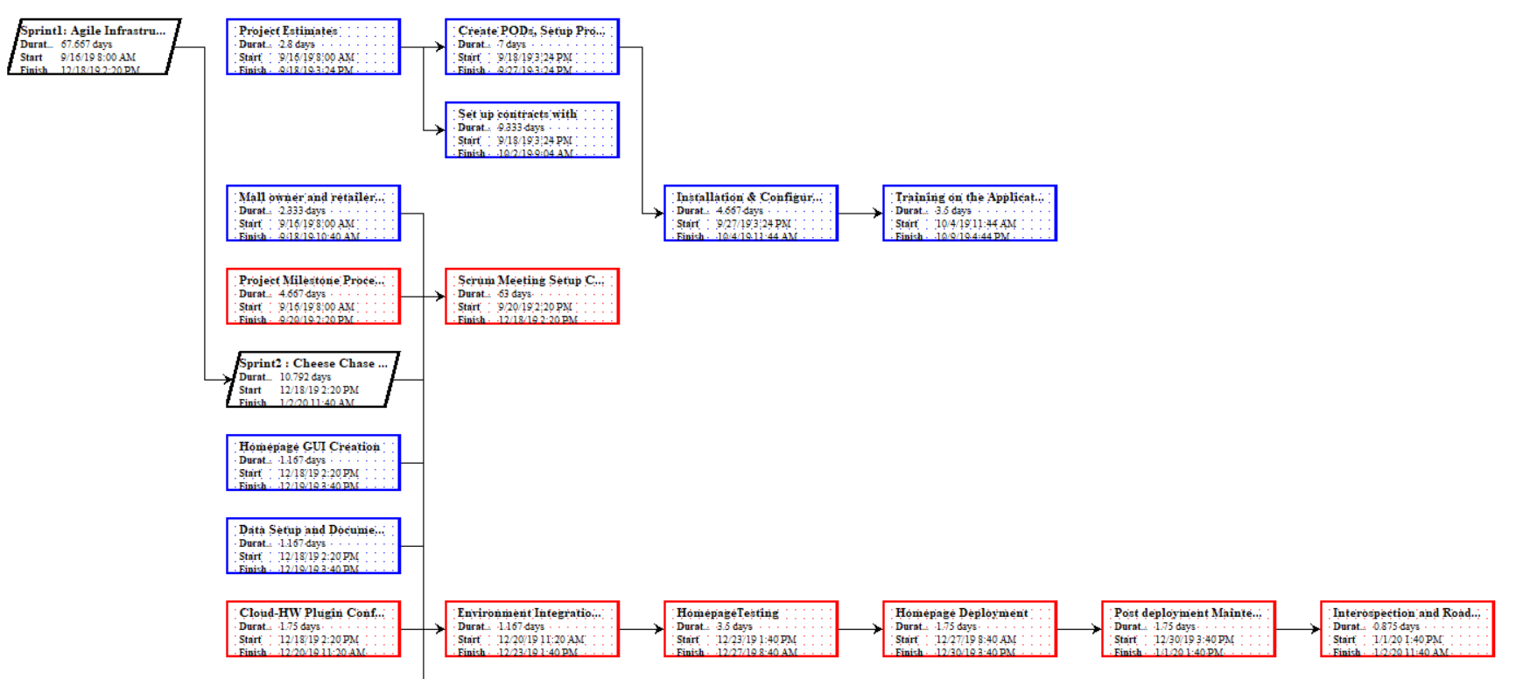 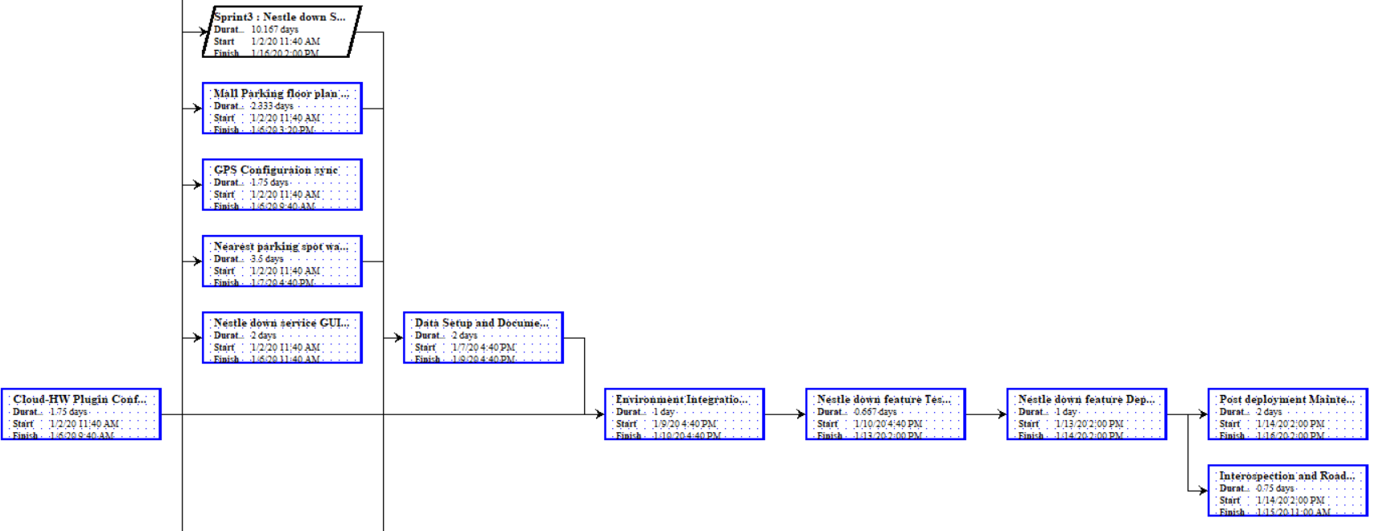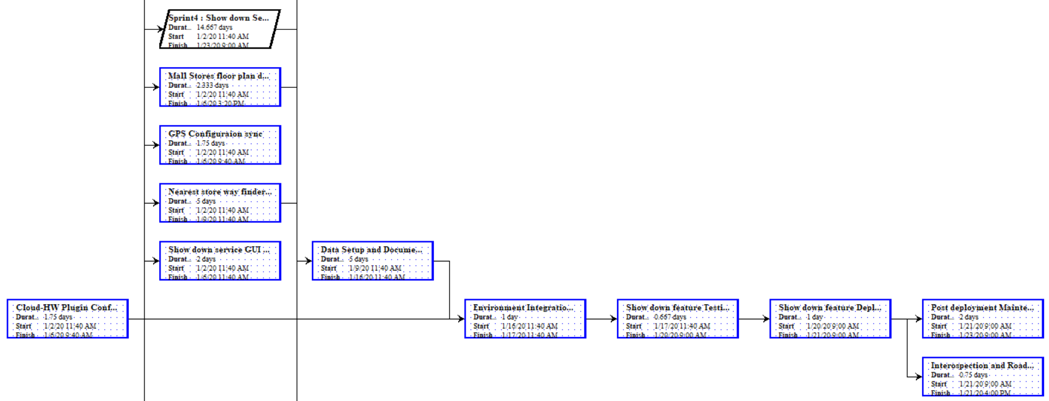

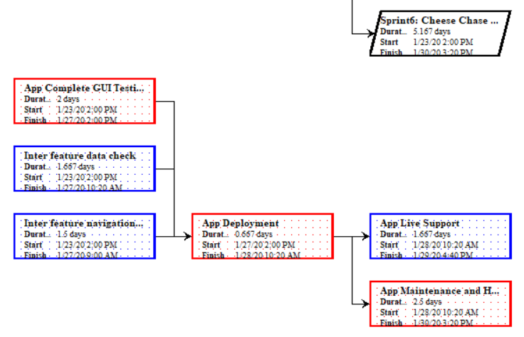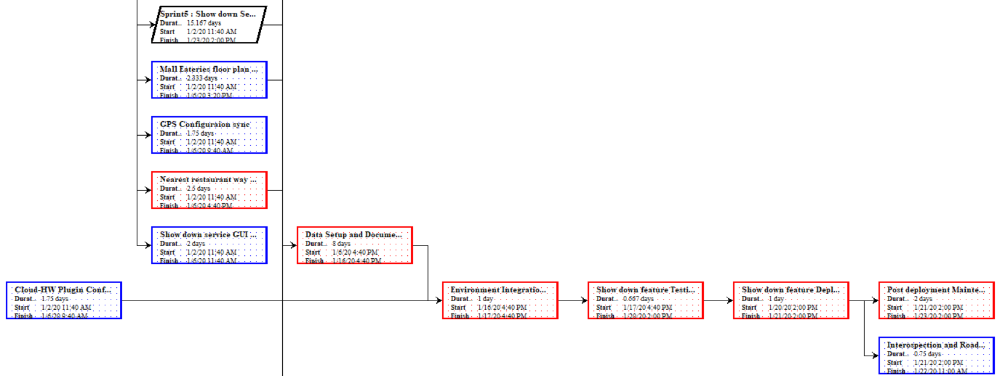

## Estimate Activity Resources

A Resource chart assists with budgeting, wage splits and resource management of the project. We will go in-depth into resource management in the HR section. The cost represented in the chart is not accurate and is on the higher end in order to avoid budgeting discrepancies.

### Figure #3: Resource Chart

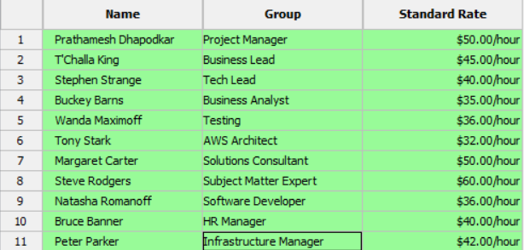

## Estimate Activity Duration

The length and **OpEx** (Operational Expenditure)of the project is estimated by using detailed analysis of **Schedule** and **Budget.** During the preliminary meetings, we have a project predesign phase wherein all the respective teams pitch in their ideas, timescales and budget in order to maintain efficiency from Day 0. This gives us ample time if the need arises to incorporate updates and additions.

## Develop a Schedule

### Figure #4: Gantt Chart

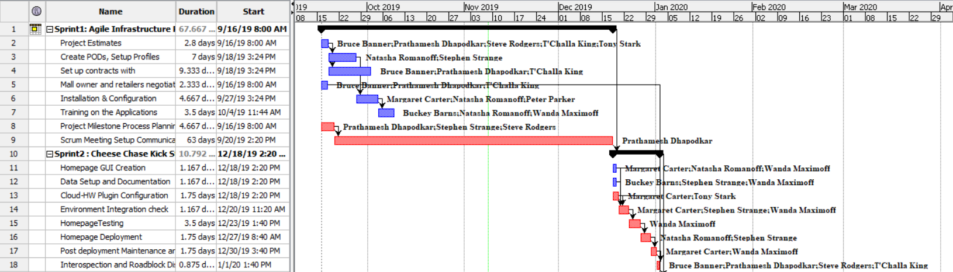 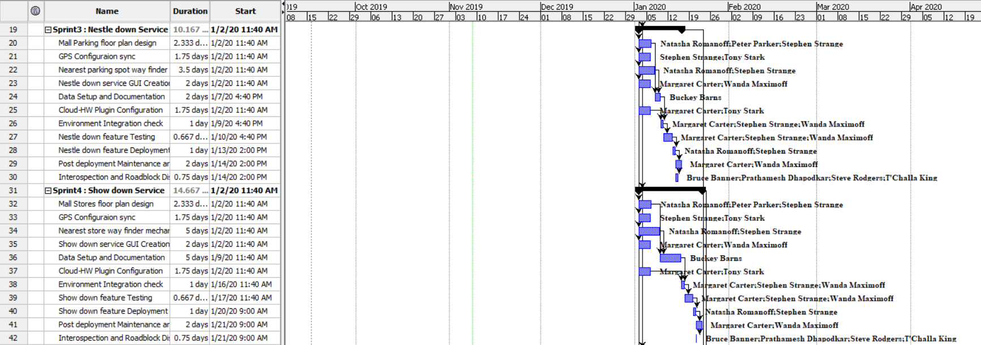 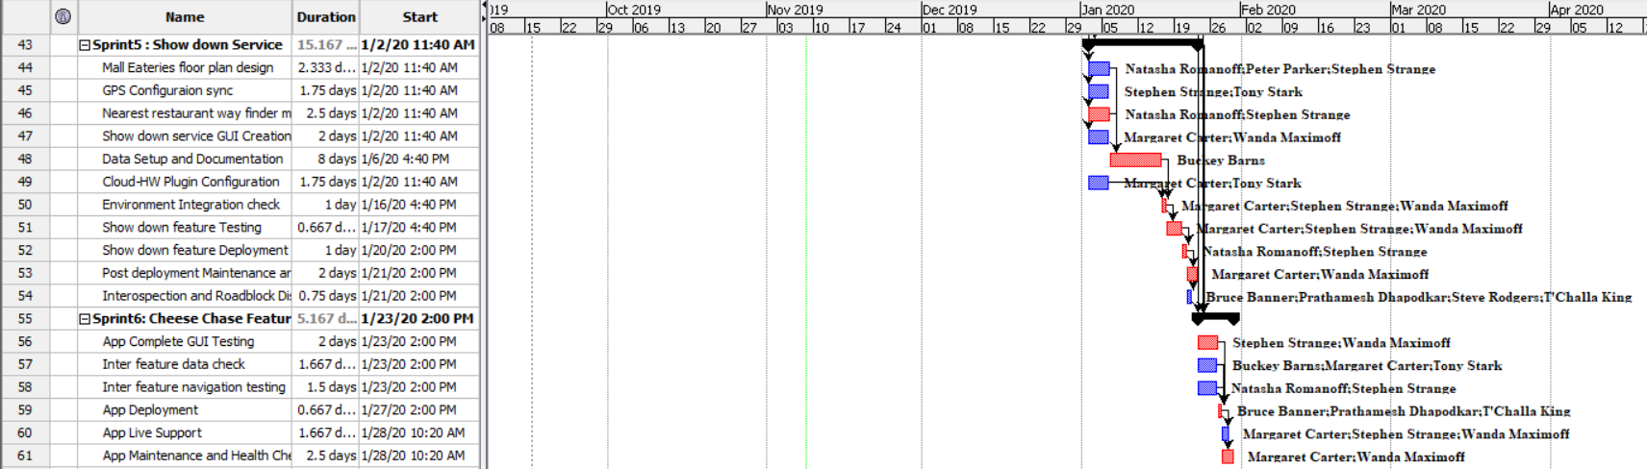

We have used Project Libre to generate Gantt Chart. Project Libre is a project management tool which has many pros. It is Open Source and thus economically viable. It is also robust and allows for flexibility in scheduling and budgeting. Cheese Chase is divided into 6 sprints. Due to the dependent nature of the activities, we have multiple milestones which are of a floating nature. Since there is minimal risk factor in terms of natural causes, our activities are expected to proceed on schedule and not get diverted.

## Control Schedule

In Cheese Chase, the project manager has complete discretion to control the schedule and ensure timely delivery of activities. PM also has the ability and authority to bring out critical situations and streamline them according to the current scenario. The PM should conduct weekly scrum meetings to analyze the progress of the project and to ensure that the project is on schedule and within budget. All the necessary reforms will be discussed in these scrum meetings. Moreover, team leads should follow the reforms requested by the PM while giving their opinions on it. Change Reports must be documented for future reference. Success of project depends heavily on communication and time management.

# Cost Management

Cost management helps us determine the estimated budget, funding and financial constraints of the project. This is crucial in order to ensure that all the tasks are completed within allocated budget. The tolerance of errors is very low since we require more of technical funding rather than logistical or physical funding.

## Estimated Budget

Our estimated budget is generated towards procurement of the following hardware and services –

* Hardware Maintenance
* Wages
* Software
* Agile Tools
* Cloud Services
* Navigation Services
* Infrastructure
* Consultants
* Miscellaneous

## Monitoring/Controlling Budget

Based on the above-mentioned list, overall budget is determined using graphical representation(S-Curve) and by generating a time-phased budget document.

### Figure #5: Time-Phased Budget

|  |  |
| --- | --- |
| **Type** | **Budget ($)** |
| Hardware Maintenance | 30,000 |
| Wages | 100,000 |
| Software | 10000 |
| Agile Tools | 2000 |
| Cloud Services | 10000 |
| Navigation Services | 5000 |
| Infrastructure | 50000 |
| Consultants | 50000 |
| Miscellaneous | 30000 |
| Total | 287,000 |

### Figure #6: S-Curve

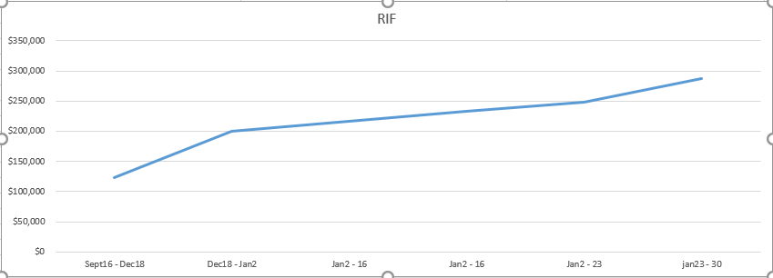

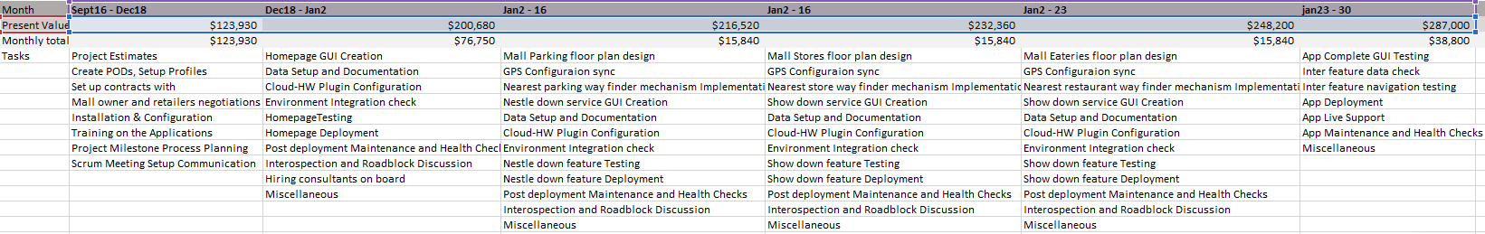

### Figure #7: Planned, Earned, Actual Value Calculations

|  |  |  |  |  |  |  |
| --- | --- | --- | --- | --- | --- | --- |
| **Month** | **Sept 16 – Dec 18** | **Dec 18 – Jan 2** | **Jan 2 – Jan 16** | **Jan 2 – Jan 16** | **Jan 2 – Jan 23** | **Jan 23 – Jan 30** |
| **Planned Value** | 123930 | 200680 | 216520 | 232360 | 248200 | 287000 |
| **Earned Value** | 123930 | 200680 | 216520 | 232360 | 248200 | 287000 |
| **Actual Value** | 123800 | 200500 | 216570 | 232360 | 248200 | 286740 |

*Estimated Cumulative Completion/ Earned Value

|  |  |
| --- | --- |
| **Calculation** | **Value ($)** |
| Cost Variance = Estimated Values – Actual Cost | 260 |
| Cost Performance Index = Estimated Value/ Actual Cost | 1.00 |
| Scheduled Variance = Estimated Values – Planned Value | 0 |
| Schedule Performance Index = Estimated Value/ Planned Value | 1 |

*Calculations based on estimated cost

# Quality Management

## Plan

Quality Management is essential in order to make sure that the project is up to par with internationally accepted standards, objectives and responsibilities assigned at the start of the project. Quality Assurance is a major part of managing the quality of a project. There are multiple metrics to measure the quality of a project, such as, cost of quality, management responsibility, etc. Maintaining Quality ensures consistency of expenditure and makes sure that the tasks are being completed within budget and on time. It also helps us make improvements in the project. This eliminates the need for constant backtracking and the costs involved in it. Project Managers use multiple checklists to control and maintain the quality of the project.

## Quality Checklist

Before we proceed further, as per the PMBOK, we need a checklist to verify whether everything is in place. Below is the checklist.

### Figure #8: Quality Checklist

|  |  |  |  |  |  |  |  |  |  |
| --- | --- | --- | --- | --- | --- | --- | --- | --- | --- |
| **Project Management Checklists** | | | | | | | | **Complete** | **Initial** |
| **Project Integration Management** | | |  |  |  |  |  |  |  |
|  | Project Charter, Preliminary Scope Statement, |  |  |  |  |  |  | x | BG |
|  | Project Management Plan, Direct/Manage Project Execution, |  |  |  |  |  |  | x | BG |
|  | Monitor/Control Project Work, Integrated Change Control, |  |  |  |  |  |  | x | BG |
|  | Close Project |  |  |  |  |  |  |  | BG |
| **Project Scope Management** | | |  |  |  |  |  |  |  |
|  | Scope Planning, Scope Definition WBS, |  |  |  |  |  |  | x | BG |
|  | Scope Verification, Scope Control |  |  |  |  |  |  | x | BG |
| **Project Time Management** | | |  |  |  |  |  |  |  |
|  | Activity Definition, Activity Sequencing, Activity Resource Estimating, |  |  |  |  |  |  | x | BG |
|  | Activity Duration Estimating, Schedule Development, |  |  |  |  |  |  | x | BG |
|  | Schedule Control |  |  |  |  |  |  | x | BG |
| **Project Cost Management** | | |  |  |  |  |  |  |  |
|  | Cost Estimating, Cost Budgeting, Cost Control |  |  |  |  |  |  | x | BG |
| **Project Quality Management** | | |  |  |  |  |  |  |  |
|  | Quality Planning, Quality Assurance, Quality, Control |  |  |  |  |  |  |  | BG |
| **Project Human Resource Management** | | |  |  |  |  |  |  |  |
|  | Human Resource Planning, Acquire Project Team, |  |  |  |  |  |  | x | BG |
|  | Develop Project Team, Manage Project Team |  |  |  |  |  |  | x | BG |
| **Project Communications Management** | | |  |  |  |  |  |  |  |
|  | Communications Planning, Information Distribution, |  |  |  |  |  |  | x | BG |
|  | Performance Reporting, Manage Stakeholders |  |  |  |  |  |  | x | BG |
| **Project Risk Management** | | |  |  |  |  |  |  |  |
|  | Risk Management Planning, Risk Identification, |  |  |  |  |  |  | x | BG |
|  | Qualitative Risk Analysis, Quantitative Risk Analysis, |  |  |  |  |  |  | x | BG |
|  | Risk Response Planning, Risk Monitoring and Control |  |  |  |  |  |  | x | BG |
| **Project Procurement Management** | | |  |  |  |  |  |  |  |
|  | Plan Purchases and Acquisitions, Plan Contracting, |  |  |  |  |  |  | x | BG |
|  | Request Seller Response, Select Sellers, Contract Administration |  |  |  |  |  |  | x | BG |
|  | Contract Closure |  |  |  |  |  |  |  | BG |

## Monitor and Control

Quality Control and Assurance is done so that customer satisfaction is guaranteed. The aim of the project is to provide services of high standards without any hassle to the customers. This also helps in ensuring that customer feedback is productively used to make improvements. So, the project manager’s role is vital to project execution.

# Human Resource Management

## Plan

In order to successfully complete this project, we need a considerable large team of experts. To manage the workflow of the team we need human resource management which ensures the smooth working of the team.

## Team Members and Responsibilities

|  |  |
| --- | --- |
| **Role in Project** | **Expectation of Project** |
| Project Manager | Manages Scrum meetings and checks on project status. |
| Business lead | Observes the progress of the project based on business needs. |
| Tech Lead | Manages the development of the project. |
| Business Analyst | Bridges the gap between developers and business. |
| Testing Manager | Leads the testing department for implementation. |
| AWS Architect | Develops and manages the cloud for the project. |
| Solutions consultant | Monitors the smooth functionality of the project based on business standards of the company. |
| Subject Matter Expert | Manages advising and training departments. |
| Senior Software Developer | Manages the development of the project. |
| HR Manager | Manages the workforce and checks the smooth functioning among stakeholders. |
| Infrastructure Manager | Manages the administration and onsite requirements based on structural requirements. |

### Figure #9 – Responsibility Matrix

In the table below, ✔ means there is an involvement of the designated person.

|  |  |  |  |  |  |  |
| --- | --- | --- | --- | --- | --- | --- |
| Designation | Sprint1 | Sprint2 | Sprint3 | Sprint4 | Sprint5 | Sprint6 |
| Project Manager | ✔ | ✔ | ✔ | ✔ | ✔ | ✔ |
| Business Lead | ✔ | ✔ |  |  |  | ✔ |
| Tech Lead | ✔ | ✔ | ✔ | ✔ | ✔ | ✔ |
| Business Analyst | ✔ | ✔ | ✔ | ✔ | ✔ |  |
| Testing Manager |  | ✔ | ✔ | ✔ | ✔ | ✔ |
| AWS Architect | ✔ | ✔ | ✔ | ✔ | ✔ | ✔ |
| Solution Consultant |  | ✔ | ✔ | ✔ | ✔ | ✔ |
| Subject Matter Expert | ✔ | ✔ | ✔ | ✔ | ✔ | ✔ |
| Senior Software  Developer |  |  | ✔ | ✔ | ✔ |  |
| HR Manager | ✔ | ✔ | ✔ | ✔ | ✔ | ✔ |
| Infrastructure Manager | ✔ | ✔ | ✔ |  |  |  |

Sprint 1: - In this milestone we conducted preliminary meetings, budgeting, planning, hiring contracts, acquiring tools and equipment’s.

Sprint 2: -In this milestone we start the project by developing UI, configuration of software, designing database, setup of environment, preliminary test and introspect the result for changes and documentation.

Sprint 3: -In this milestone we developed the structure for nearest parking spot finding mechanism and synchronize it with GPS and integrating with cloud finishing it with testing.

Sprint 4: - In this milestone we developed the structure for showing mall stores and synchronize it with GPS and integrating with cloud finishing it with testing.

Sprint 5: -In this milestone we developed the structure for showing restaurants in the mall and synchronize it with GPS and integrating with cloud finishing it with testing.

Sprint 6: - In this milestone we tested the integration and features of the software. After which we deployed the application and made it go live.

# Communication Management

## Plan

Communication is essential since it is responsible for keeping all the key stakeholders informed. It helps in understanding the progress of the project and helps establish a rapport between the team and senior management. The various forms of communication include daily scrum meetings, emails, status reports, text messages. This helps in isolating minute problems which may go unnoticed without proper communication.

### Figure #10: Communication Plan

|  |  |  |  |
| --- | --- | --- | --- |
| **Project Phase** | **Information Provider (the sources)** | **Frequency** | **Method of Communication  (the media)** |
| Project Initiation | Business, Scrum master | Once a week | Meeting, Formal update |
| Project Planning meeting | Scrum master | Once a week | Meeting, Formal update |
| Project Kickoff/Prep | Scrum master | Once a week | JIRA, Confluence |
| Daily Scrum | Scrum master | Daily | Standup meeting, JIRA, Confluence |
| Sprint Milestone Check | Business, Scrum master | Bi-weekly | JIRA, Confluence |
| Sprint Release review | Business, Scrum master | Once a week | Meeting, Formal update, JIRA, Confluence |
| Sprint retrospective | Scrum master | Once a week | Formal update |
| Sprint Closure | Business, Scrum master | Once a week | Meeting, Formal update, JIRA, Confluence |

Daily Scrum meetings are essential because they help in understanding the completion of milestones. They are also essential in establishing day to day goals, updates and ease out the work environment.

# Risk Management

With the help of risk management gate, we can analyze, identify and mitigate potential risks in order to avoid glitches and bugs. It is highly recommended to continuously monitor for potential risks at every stage in order to stay ahead of the curve. Risk register helps us understand and manage risk in an efficient manner.

### Figure #11: Risk register

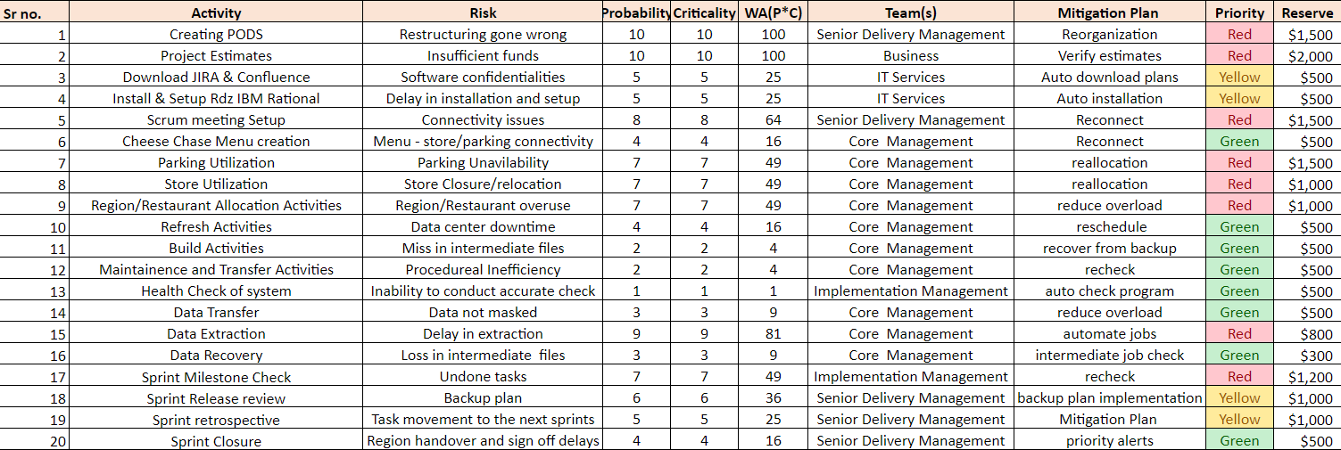

This table depicts the implications of risk on the project

* Red – High Risk
* Yellow – Moderate
* Green – Low

Risk is mitigated based on the assigned color codes as depicted above.

# Procurement

Procurement can be divided into 4 steps i.e. planning, conducting, controlling and closure in order to successfully implement it. We will start this process by planning which is explained below.

## Plan

In this section we elaborate on how the purchase of materials will be done i.e. to outsource or subcontract the requirements. First the team will decide on what needs to be outsourced and what can be subcontracted looking at the availability of materials. Outsourcing or subcontracting requires a careful monitoring for quality checks and risks. Also, a strong agreement needs be made with the vendors for data privacy and security to assure the quality of the product. Below is the list of materials that will be outsourced and subcontracted.

## Outsourced Purchase

The requirements that will be outsourced includes: -

1. Equipment Requirements (IBM Equipment’s)
2. Project Dashboard Software (Confluence)
3. Project update platform (JIRA)

## Subcontracted Purchase

The requirements that will be subcontracted includes: -

1. Cloud Platform (Amazon AWS)
2. Development Platform (Mendix)

## Conduct Procurement

The project manager along with the team lead is responsible to get the quotes from various vendors and try to obtain the lowest price of software and hardware that will be needed. While trying to obtain the lowest price they should not compromise the quality of the product. Price can vary and can go up over a period of time if new requirements come into picture or if more resources are required then previously planned. The following table shows the expected delivery time and the type of contract.

### Figure #12: Expected Delivery Times and Contracts

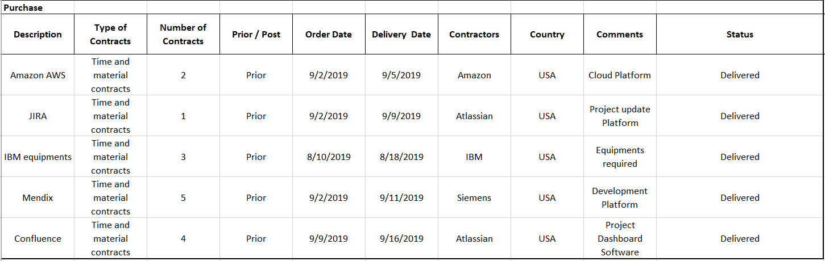

Before finalizing the contract, a procurement chart is used for selection. For this project we have narrowed down our subcontract and outsourced contracts to 6 options to perform an analysis which is as shown below.

### Figure #13: Procurement Plan

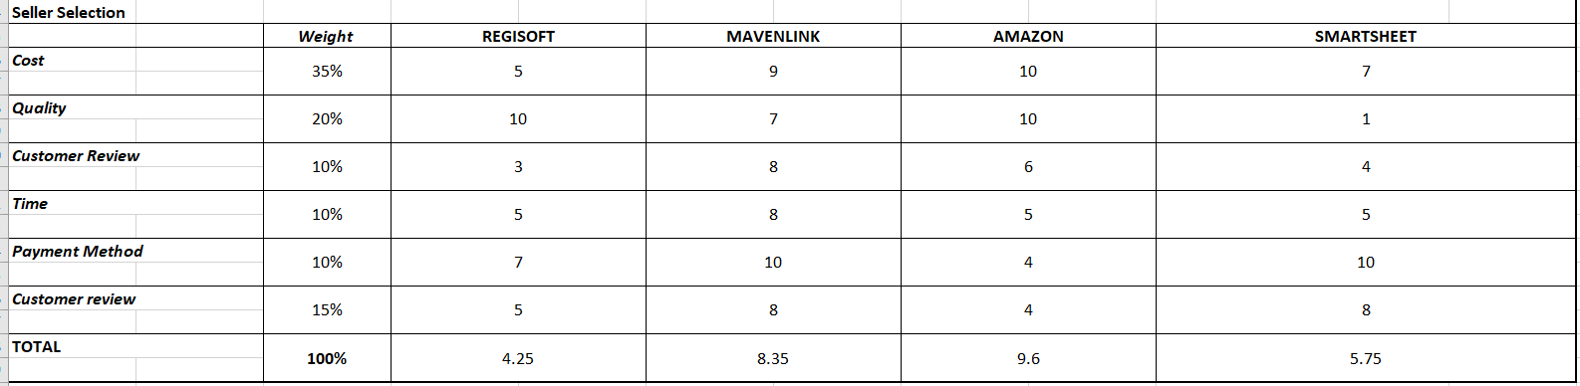

For our cloud service decision, after comparing all the contracts and putting weights against all the 6 options it was clear we need to use Amazon. The weights assigned for the project where calculated using prior knowledge where 1 is the least trusted and 10 is the most trusted.

## Control and close procurement

To minimize the risk and have control over the procurement one needs to carefully create contracts and document everything. Also, to make sure all the standards are followed, and all contract requirements are fulfilled the project manager needs to keep a timely check on it. Heavy emphasis needs to be made on the quality of the software by testing it time and again. For closing the project with the contractors, a 30% retention must be kept a side and will be paid after 2 months of availing all the requirements.

# Stakeholder Analysis

A stakeholder is a person or a group of persons that are affected by the outcome of the project. In order to successfully complete the project, it is important to understand the stakeholders of the project and meet their needs. Important stakeholders of this project include the sponsor, Rocky Mountain Technologies, project manager, developers, consultants, testers etc. The following figure organizes the stakeholders by their interest, influence and the amount of information that needs to be provided to them. The graph organizes the stakeholders into 4 different categories i.e. keep satisfied, manage closely, monitor and keep informed.

### Figure #14: Stake holder Influence vs. Interest Analysis Map

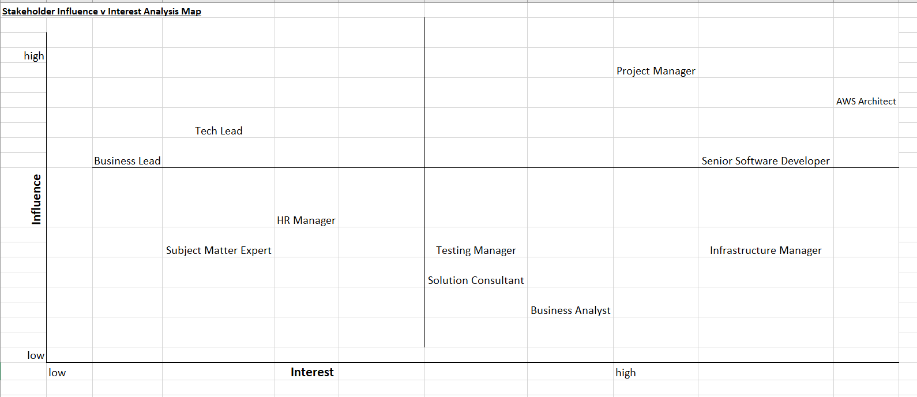

Keep Satisfied: The top left area of the graph represents entities with high power and low influence. The stakeholders falling in this area can directly influence the project and have higher authority but prefer to remain in the background unless necessary. Team Lead and Business Lead are the stakeholders who fall in this category.

Manage Closely: The top right area of the graph represents entities with high power and high influence. The stakeholders falling in this area are the most aggressively involved in the project and it is necessary to keep them in the loop at every turn. Project Manager, AWS architect and Senior Software Developer are the stakeholders who fall in this category.

Monitor: The bottom left area of the graph represents entities with low power and low influence. The stakeholders falling in this area are not capable of highly influencing the project and have the least interest in the project. HR Manager and Subject Matter Expert are the stakeholders who fall in this category.

Keep Informed: The bottom right area of the graph represents entities with low power and high influence. The stakeholders falling in this area are not capable of highly influencing the project but have the most interest and will stand to gain or lose the most depending on the outcome. Infrastructure Manager, Solution Consultant, Testing Manager and Business Analysts are the stakeholders who fall in this category.

# Lessons Learned

From this class I have learned valuable information about project management. I have learned about the importance of the 10 knowledge areas from the PMBOK in creating a successful project. I have also learned the importance of communicating and working well within a group to make sure the project runs smoothly. Learning about how to approach any project through the knowledge areas will help me to be able to create and manage projects more successfully in the future.

-Tae Kim

From this project, I have learned how to yield maximum output from a project while incurring the least amount of risk. Also, it has become clear that Quality is of utmost importance in the project. The ten knowledge areas from the PMBOK are now very clear to me.

-Anirudh Sundar Rajan

After taking this class and upon completion of this project I have learned how important teamwork is for managing a project. Also, when it comes to project management it’s not just one or two parts of the project management that make it successful but it’s the combination of all the 10 knowledge areas mentioned in the PMBOK that needs to be in place in order to get the best results. One of the knowledge areas that caught my attention while preparing this notebook is stakeholder analysis which shows how important it is to categorize all the stakeholders as per their role in order to keep everyone on board happy and satisfied.

-Kunal Chetankumar Naik

This class made me understand the importance of project management and how it is done. I learned about how to make a good, successful and efficient project using the 10 knowledge areas from the PMBOK. It will help me in the feature in being a team player and implementing these factors in feature projects.

-Prathamesh Dhapodkar

# References

# A guide to the Project Management Body of Knowledge (PMBOK guide) (6th Ed.)

# Software Project Management Plan (v1.2a) (BOTS-SPMP)

# Sliger, M. (2011). Agile Project Management with Scrum. Paper presented at PMI.

# Acknowledgements

# Bob Kois – University of Colorado Denver